**Schemas**

A given Oracle database can store the objects associated with a single installation of Oracle E-Business Suite. In general, product *code* objects are stored in the *APPS schema*, whereas product *data* objects are stored in the relevant *base product schemas*.

**The APPS Schema**

The APPS schema has access to the complete Oracle E-Business Suite data model. It is analogous to the SYSTEM schema, which has access to the entire database. Oracle E-Business Suite responsibilities connect to an APPS schema, and the environment variable FNDNAM is set to the name of the APPS schema. The APPS schema owns all the code objects for the Oracle E-Business Suite, and has access to all data objects. There is one APPS schema for every product installation group.

Utilizing a single schema that has access to all objects avoids cross-product dependencies. The APPS schema also improves the reliability of and reduces the time needed for installation, upgrading, and patching, by eliminating the need for cross-product grants and synonyms.

The following code objects are installed in the APPS schema:

* Packages
* Procedures
* Functions
* Triggers
* Views
* Materialized views
* Java classes
* Queues

**Base Product Schemas**

All data objects for a product are owned by a specific schema for that product, known as the base product schema.

The following objects are installed in the base product schemas:

* Tables
* Sequences
* Indexes
* Constraints
* Queues

**Relationship Between APPS Schema and Base Product Schemas**

The base product schemas also contain grants from various tables and sequences to the APPS schema, as well as synonyms from the APPS schema to the same objects.

**Figure 3-1 APPS Schema and Base Product Schemas**

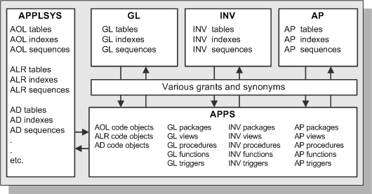

## Custom Schema Access

In some circumstances, you may wish to create a schema that has limited or read-only access to Oracle E-Business Suite data.

**Warning:** Since the APPS schema has all privileges to all Oracle E-Business Suite objects, you should never give users(customized new users/schemas) direct access to this schema.

You will need to grant access on objects from the base product schemas to the new user schema.

**Note:** You may need to re-grant access if the underlying object is dropped and recreated.

## 

## Oracle User IDs

Each Oracle E-Business Suite product has a default Oracle user ID, with the product abbreviation used as both the schema name and password. For example, the default Oracle user ID/password combination for Oracle General Ledger is *GL*/*GL*.

**Important:** For security, you should change the default passwords immediately after installation. However, Oracle recommends that you do not change the default user IDs.

A product's schema determines the ownership of the product's data objects, such as sequences, tables, and indexes. If two products are installed under the same schema, that schema owns the data objects for both products.

Since a product's data objects are created in their own schema (such as the GL schema), but the user accesses all data objects through the APPS schema, appropriate grants and synonyms are required between the APPS schema and the base product schemas.

### Introduction to Tablespaces

An Oracle 11*g* database always requires the following tablespaces to be available:

* **System Tablespace** - This tablespace holds data dictionary tables owned by the SYS account, and is created when the database is installed.
* **Undo Tablespace** - This tablespace holds undo (rollback) information that is used to track database changes until they are either committed or undone (rolled back).
* **Temporary Tablespace** - Temporary tablespaces are used to sort data while it is being processed. It is possible to use a single temporary tablespace, typically called TEMP, for all Oracle E-Business Suite products. Alternatively, separate temporary tablespaces can, if desired, be created for individual products. Since users access Oracle E-Business Suite objects through the APPS schema, the temporary tablespace for that schema (initially the same as that for the Oracle Application Object Library) is used by all products.

The traditional Oracle E-Business Suite tablespace model employed separate tablespaces for a product's tables and indexes. The resulting tablespaces were named by appending 'D' for data or 'X' for an index to the product's short name or Oracle schema name. For example, APD was the tablespace for Oracle Payables data, and APX was the tablespaces for Oracle Payables indexes.

Employing separate table and index tablespaces for each product made it easier maintain products, and helped to improve database performance. However, with an increasing number of products, this model could easily require several hundred product tablespaces, plus a system tablespace, undo (rollback) tablespace, and temporary tablespace.

During installation, Rapid Install provides the option of distributing tablespaces across different disks, to reduce disk head contention and improve overall system performance. In addition to this, many production systems utilize sophisticated disk and volume management technologies at operating system level to further enhance performance.